Study Visit Report
RISE ERASMUS+ Project

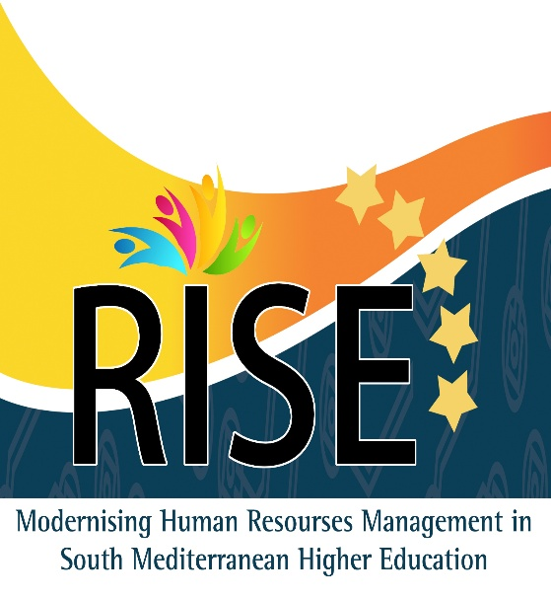 inset your logo here

To: Prof. Walid Salameh / RISE Project Coordinator
Princess Sumaya University for Technology
From: Dr. …………. / …………… University
Date: [ 20 / 5 / 2016 ]
Venue: Rouen University, France
Subject: Study Visit Report (Rouen University, Rouen, France, 9th – 14th May, 2016)

Summary:

Points:

Tuesday 10th May
The event started with. ………………………….
This is followed by a presentation from …….. was an overview about the ……..
The second talk was about ………….
The third presentation was given by ……….
The next session was ………………..

***** Add pictures of the first day

Wednesday 11th May
The first presentation started by ……………….
The second talk was about ………….
The third presentation was given by ……….
The next session was ………………..

***** Add pictures of the second day

Thursday 12th May
The first presentation started by ……………….
The second talk was about ………….
The third presentation was given by ……….
The next session was ………………..

***** Add pictures of the third day

Friday 13th May
The first presentation started by ……………….
The second talk was about ………….
The third presentation was given by ……….
The next session was ………………..

***** Add pictures of the second day

Conclusion:
First, we would like to thank the project coordinator for this informative and amazing visit to Rouen University. ……………..
The lectures were valuable. Here are some points that also conclude the scientific visit:
- The event was nicely organized.
- The presentations were related to the subject and informative.
- The visit was a very good opportunity to make warm discussions with the European delegates.
- We should conduct several training courses for our university staff to involve them more in the RISE project.

Recommendations:
- We suggest ………...
- It's important to determine the Know-How to develop ………….
- Visiting other countries of EU for the same purpose would be of great help.
- ……..
- …………

Signature

