In the Name of God, Most Gracious, Most Merciful
Visit to Tunisia
From: Dr Mahmoud Owaydah, Reem Albasha and Shadi Mohammad / Princess Symaya University for Technology.

First day: Monday, 8/8/2016
Opening
Prof. Waleed Salameh:
Prof. Waleed Salameh opened the workshop. He welcomed professor vice-president of the University of Monastir as well as the participants in the workshop, wishing it success. Then, he pointed out the workshop’s importance, which emanates from dealing with an important subject in HR management in higher education institutions: “Effective means in setting strategic plans for HR management”. He went through the workshop’s schedule, emphasizing the necessity of interaction with the subjects being posed, as well as the adherence to becoming acquainted with the experiences of others, especially from European countries, such as France and Germany.
Vice-president of the University of Monastir:
He welcomed the participants, also emphasizing the importance of the workshop, which will discuss the strategic plans for HR management in higher education institutions, particularly those of North African countries, since this subject represents a special priority for those countries. Then, he pointed out that the schedule has been designed by the Princess Sumaya University for Technology (PSUT) and the Europeans, presenting thanks to PSUT as well as to its president prof. Mashhour Al-Rifa’i. Then, he concluded his speech wishing all success.
First Session:
Ammar Thalji Laghouat / Algeria:
The speaker in the name of the university pointed out the importance of HR management in general and at Laghouat University in particular, stating that the HR plan at Laghouat University is in integration with the general plan of the university. In addition, the HR plan includes other indicators, such as the development of human resources, student services and financial issues.
He also appreciated the different functions of HR management, such as appointments, job security and working force planning and development>

University of Monastir / Tunisia:
The appointment mechanism at the university has been gone through, including the appointment of faculty members and administrative staff. It was pointed out that the ministry of higher education and scientific research is the organizing entity of this task, through assuming responsibility of advertisement according to vacancy, determination of each vacancy’s requirements, studying the applications and completion of appointment procedure. In relation with the appointment of administrative staff, there are two appointment types; internal appointment and external appointment, due to the specifications required for each vacancy, such as certification type, number of experience years and training certificates. Reviewed were also the HR strategies having been developed to support the organizational strategy in cooperation with the ministry of higher education and scientific research to determine training needs and organize training courses.

Sultan Molai Suleiman University / Morocco:
First, it was pointed out that the university was established in 2007 and was one of the main colleges of the University of Al-Qadi Iadh. Then, the biography of Sultan Molai Suleiman was discussed his birth, life and death. The speaker also talked about the region of Bani Hilal, in which the residence of the university exists, as well as the features and resources of this region. Currently, the university includes several colleges; IT colleges, college of human sciences, multi-specialization college and the higher school of technology. The university employs about 300 faculty members and offers its educational services to about 2500 male and female students. The, the HR strategy at the university was reviewed, as well as the mechanisms of training and scientific research at the university and its main partners in development (12 Tempus projects, AUF, e-Omed, Microsoft, Google, 4 Erasmus projects).
Further, the HR department at the university started to use the ERP system, which in turn includes a group of administrative units that use this application.
The importance of integration between HR management strategy and information systems was also emphasized, especially as the university endeavored since 2010 to apply them to determine the qualifications of vacancies, invest in the training process, organize the employment process and encourage scientific research, in consistency with the university’s strategy.

Ministry of Higher Education and Scientific Research/ Jordan:
The presentation was opened with an introduction on the importance of building the capabilities and skills of employees, as well as the teamwork in HR management, since employees are the real wealth of any institution. Then, the organization structure of the ministry was presented and that of the HR department at the ministry explained, where the HR department consists of the institution development section, the HR development section and the HR management section. Furthermore, the ministry’s vision and mission were presented, which can be summarized in rooting the culture of excellence and innovation, scientific research and coping with advances and national needs. Emphasis was placed on that any successful administrative leadership has to follow up the tasks of organization, planning, guidance and supervision. In order to assume an efficient role, the HR department must have highly skilled personnel, as well as clear instructions and institutionalization in connection with organizational structure, information flow and acquaintance with the surrounding environment. It was pointed out that the HR department at the ministry is currently responsible for preparing the annual training plan according to the training needs. Then, the relationship between the HR development and the other departments and directors was explained; in terms of determining the needs and required skills for the employees of each department or directorate, through applying the HR management experiences after obtaining feedback.

Second Session:
University of Magdeburg:
The presentation started with an introduction on the ERP system.
- It was made clear that the view towards HR management has changed from being a pure administrative task into an intelligent set of patterns, means and steps that lead to reducing cost and time required to finish tasks as well as increasing benefit and innovation by employees.
- Implementation strategies, which come in three steps; either the corporation itself has acquired experience and is therefore the implementor, or the corporation signs a contract with the system sellers, or it assumes implementation through consultants who are specialized in such systems.
Then, there are several stages to implement the system, where each of the stages includes a detailed work plan.
These stages can be summarized as follows:
- Project preparation:
Project scope determination, setting the project plan (time, budget, etc), appointment of project team members, and determination of main performance indicators to assess the project success.
This process is a process of system production, which consists of actual usage of the institution resources determination system after implementation, as well as the system testing and the system development. Then, this stage is completed after assuring its quality.
- Project planning:
It is necessary to analyze and design the work, determine and document the processes, prepare forms like those of organizational structures and job sequence, … etc. and thereafter establish work bundles through enhancing the system, determining the organizational structures and identifying the programs required to transfer and convert data from the formerly used system, with assuring quality at the end of the stage.
- Project Implementation:
This stage includes applying the requirements, specifications, and design having been documented in the work plan, as well as forming a version of the appropriate main program, talking the suitable measures in association with the jobs not included in the program, establishing the work bundles through training the project team, establishing the settings for the programming system as specified in the project planning stage and updating the programs.
- Final Preparation:
This stage includes the establishment of an efficient system that is ready to initiate work, the transfer from the previous system to the new one, emphasizing the necessity of taking care of information transfer, the training of the system users, testing the system and assurance of quality.
- Execution Time:
It should be ensured that the system operates in a stable and efficient manner; where the purpose of the system is to support the users. The system is then developed after its operation and testing according to the presented remarks. Then, the system is finally accredited and the work team dissolved.
- Execution Costs:
These consists of:
- Direct costs, which are divided into:
- One-time costs, such as the costs of the program license, the server, the work team, technical support, training, … etc.
- Periodic costs, such as those of license renewal, program maintenance, program updating, final user support, … etc.
- Indirect costs, such as those of system breakdown, failure, performance weakness, final user retraining , … etc.

Then, an actual application example was presented, which substantiates the project implementation route and the maintenance route through the correction of failure that occurred, by means of experimentation.
Thereafter, the speaker pointed out the role of the HR system in the ERP system, in terms of determining the corporation’s organizational structures with drawing representing maps and hierarchical sequences, in addition to a detailed map of the responsibilities of employees and the conditions required to implement HR processes, including:
- Project structure; representing the determination of the official financial structure of the project, the nomination of a specific employee for the project, as well as his/her work scope and code within the corporation.
- Structure of employees; describing the position of the employee within the corporation and within the sub-group, as well as the determination of the related organizational scrolls.
- Organization’s structure; describing the job occupied by the employee and determining the organizational units, the work nature (part time/full time), the cost of each position and the tasks of employees.
Then, the processes of human capital management (HCM) were discussed.
- Management of the organization or corporation; including explain the organizational structures, establishing and determining the jobs, as well as determining each department’s needs.
- Employee affairs’ management; including the establishment and management of HR main data, as well as the detection of failures and the preparation and submittal of reports.
- Employment; including internal employment, external employment, selection of candidates and the establishment of a database of the candidates.
- HR development; including the development of HR capacities, the comparison between the job and the required qualifications, the determination of training needs, the initialization of talent development, as well as training and performance assessment.
- Intelligent management; including the implementation of fictional planning and fictional sequence (heritage or succession in the job), in addition to the creation of general and specific development plans.
- Performance management, which is accomplished according to an agreement between the corporation and the employees with the aim of increasing the incentives and enhancing the performance.
- Personal monitoring; including the submittal of reports, the assessment of HR data, the submittal of reports with specific criteria and job intelligence (functional intelligence).

Third Session:
The attendants were divided into categories or work groups in order to give a presentation from the reality of the institution planning system, which is related to some HR tasks. These groups were formed from the participating countries as follows:
- The Jordanian work team, with the task of employee assessment.
- The Tunisian work team, with the task of employment.
- The Moroccan work team, with the task of HR management.
- The Algerian work team, with the task of planning.

Second Day: Tuesday, 9/8/2016
First Session:
The session was administered by the German trainer Mr. Steffen Willy Hart, with the aim of discussing the work tasks assigned to the different teams on the previous day.
- The Jordanian work team gave the first presentation, in which the procedures of employee assessment and the application of the related processes through the ERP system; utilizing the following chart:

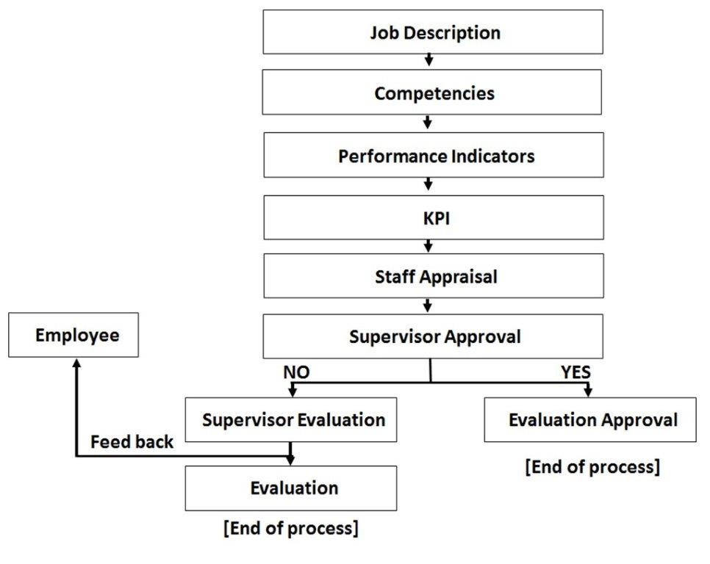
- The Tunisian work team gave the second presentation, which discussed the employment procedures; including the determination of job needs, forwarding them to the ministry for accreditation and the correspondence with the persons concerned, followed by internal or external employment; with the attempt to apply all of these procedures through the ERP system.
- The Moroccan work team gave the third presentation, in which it was pointed out that when setting objectives of HR management, these objectives have to be consistent with the university’s goals and vision and consequently with the department strategy. Accordingly, the work policies and principles are set; including HR employment (secondment, delegation, employment for the first time, exposure of employees to a testing period of one year for administrative employees and two years for academic staff). All of these procedures are applied through the ERP system.
- The Algerian work team gave the fourth presentation, in which it was pointed out that the planning process includes several procedures, which are: job analysis through the determination of needs and job specifications, job assessment, planning, employment, training and functional route determination. All of these procedures are applied through the ERP system.

The university of Roan / France:
The speaker started his speech in French, where he expressed some comments, including his objection against the previous distribution of the work teams, which have been divided according to geographic borders, although this was not the case at the beginning, where the team distribution was arbitrary. The speaker posed the question: “Why are we unable to form teams from different geographic regions although we seek to achieve the same goal?”
This question stimulated the participating teams; responding with the same answer, which was the regulations and instructions differ from a university to another, and that there is something common in the understating within the borders of each geographic region, which helps in presenting the duties or work results in a better way.
Then, the trainer started to present his subject on culture, which consists of consistent values determined by the manager. He pointed out that the learning process gives the new individual the capability of knowledge transfer, and that learning is the goal in the culture of the institution. He indicated how culture can be settled within the institution, pointing out that the paradox of culture is a recent problem which started in the 1980s in the U.S.A., and that this problem focused on who wants to drive culture in the institution with reference to the leaders, in addition to the importance of resorting to analysis means and approaches in order to confirm the institutional values.
Second Session:
In this session, the question how to deal with time was posed. It was pointed out that cultural procedures should be undertaken to help in resolving any problems associated with this issue. But, it remains difficult to change cultures in institutions. Any change should occur through achieving the goals which we believe in without harming the values which we defend. In case of inconsistency, written criteria must exist to be committed to.

Third Session:
This session was directed by Dr. Nizar Ayyadh; who presented a model of a strategic plan with a detailed explanation of the model. Then, he asked each university to establish a strategic plan for its own HR department according to the model, which tackled four important questions the answering of which enables to develop the processes of strategic planning.
- Where are we now?
- To where do we want to reach?
- How can we reach what we want?
- How ell are we doing; or how is our performance so far?

Prof. Waleed Salameh and Dr. Nizar agreed with the attendants to begin with presenting the strategies on the next day within a period of 15-20 minutes for each presentation.

Third Day: Wednesday, 10/8/2016
First Session:
In this session, the strategic plans for each university were presented according to the agreement made on the previous day, as follows:
- Tafilah Technical University / Jordan:
The strategic plan was presented using “PowerPoint”.
The presentation discussed the societal values and the circumstances surrounding the region and their effect on the institution.
- Intermediate building University / Morocco:
The strategic plan was presented according to the model suggested by Dr. Nizar. The presentation discussed the certificates presented by the general assembly, as well as the submissiveness of universities to the ministry of higher education, in addition of the ministry of technical building (training) which accredits technical certificates.
- Laghouat University / Algeria:
The strategic plan was presented according to the model suggested by Dr. Nizar. Explained were the university structure and the relation of the HR department with the other institutions, particularly in light of the fact that Laghouat region is the third gas producing region in the world. It was pointed out that the university attempts to achieve some strategies through the large numbers of students, which made it a distinguished pole in the southern Algerian region.
- Cadi Ayyad University / Morocco:
The speaker talked in French.
- The princess Sumaya University for Technology (PSUT) / Jordan
The strategic plan was presented using “PowerPoint”.
The presentation included the vision of transfer from the employee affairs section to the HR department.
Also, the presentation clarified the department’s mission and values and showed its organizational structure. Then, it switched to the strategic goals and the work plan of each goal, pointing out that each goal achieves the university’s strategy.
- Gabes University / Algeria:
The speaker talked in French.
- Monastir University / Tunisia:
The appointment procedures of academic and administrative staff members have been explained, as well as the success requirements for each job.
It was pointed out that it is often agreed upon that calling for appointment occurs through the ministry of higher education. It was explained that these procedures are connected via a detailed information system which identifies two types of codes; the first one is for individuals whose information is previously in the system and who have been re-appointed, whereas the other is a unique code for those who have been newly appointed from outside.

Second Session:
Prof. Waleed Salameh determined the dates of the coming training workshops according to the following timetable:
- October 2016 in Morocco.
- February 2017 in Estonia.
- May 2017 in Algeria.
Then, an evaluation form of the training workshop was distributed. The session and the training workshop were concluded with presenting thanks to all attendants.

