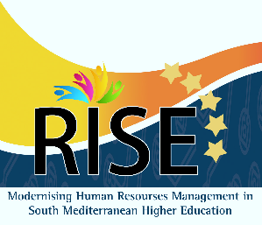

*Prof. Walid Salameh – Project Coordinator*

***Certificate of Attendance***

This Certificate is awarded to

……….

To certify her attendance to the Final Conference of RISE project held on 8-9 October 2018 in Morocco

*October 8, 2018*

Modernising Human Resource management In South Mediterranean higher Education

(RISE)

