# C. Geertz: Ethnography and the basics of *Thick Description*[1]

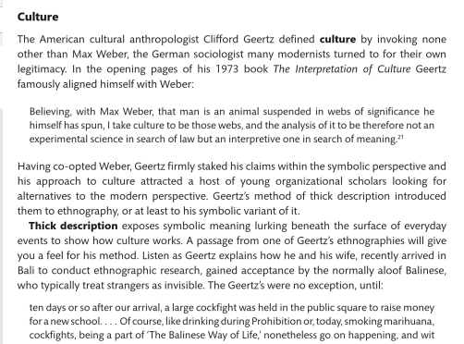

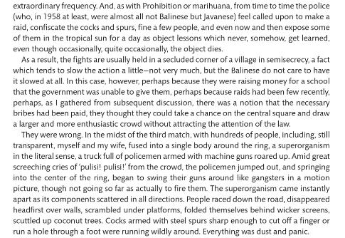

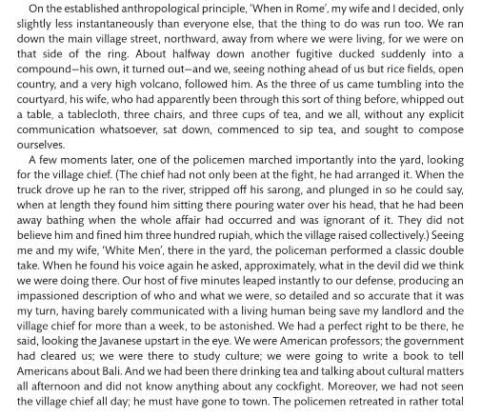

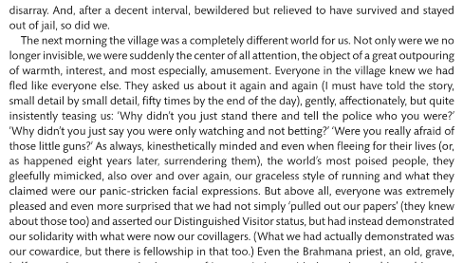

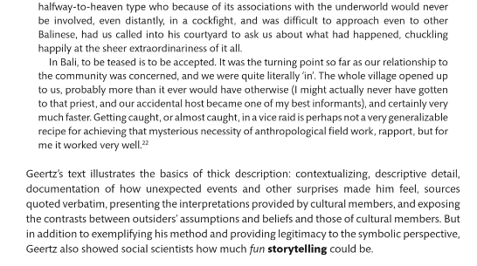

1. Abstracted from Hach and Cunliffe (2013), *Organization Theory: Modern, Symbolic and Postmodern Perspectives* (2013 : 36-37)